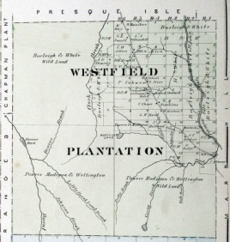
Town of Westfield Selectboard Workshop’s
Tuesday, February 4th, 2026
5:30 PM
Westfield, ME Town Office

AGENDA
- Review of Tax Assessment and Billings with Tax Accessor Becky Adam’s.
Adjournment

AGENDA
- Selectboard Budget Workshop
Adjournment

To ensure we can be as thorough as possible, the board will be working internally. While we won’t be taking public comments during this specific work session, we value input and invite you to share your thoughts at our formal Town meeting on March 16, 2026 at 7:00 PM

